**Simulating Adoption Rates of PrEP treatment as a Function of Cost To Halt Spread of HIV**

**Introduction**

According to the World Health Organization, the HIV epidemic has taken the lives of 32 million people to date; 770,000 died in 2018 from secondary infections arising in concurrence with the virus that causes HIV (<https://www.who.int/gho/hiv/en/>). PrEP (pre-exposure prophylaxis) has become a promising preventative treatment but is currently far too expensive for the demographic groups most at risk of contracting HIV. The average cost of Truvada is $2,000.00 for a 30-day supply, with the cost rising around 30% per year from $54 to $70, and insurance may not cover the cost (<https://www.goodrx.com/blog/truvada-hiv-prep-cost-generic-how-to-save/>). Descovy recently joined the class of drugs prescribed as PrEP and a generic brand is on the way.

Health care is complicated by an individual’s status as a sexual minority. Challenges compound for those with meager economic resources or few choices of medical providers. State and local government policy may facilitate access to health care or render it so expensive as to be cost-prohibitive. Simulating changes in the cost of PrEP in an agent-based model provides statistical evidence which supports initiatives to decrease the cost of preventative medication.

**Literature Review**

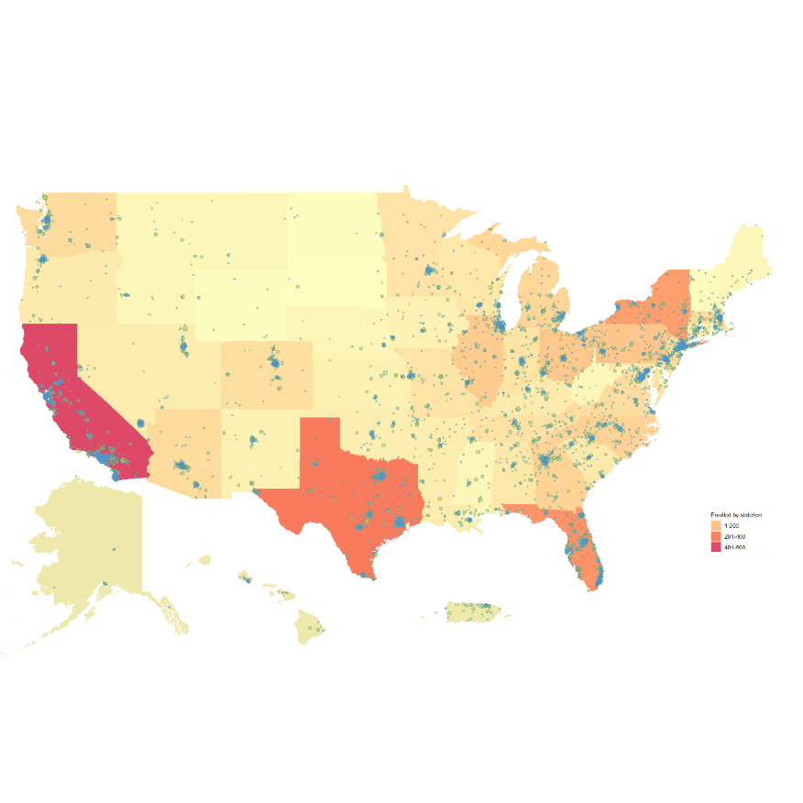

Enrolled Participants, UNITE

The question “How likely would you be to take PrEP if it were available for free?” was administered as part of UNITE, a nation-wide study of over 10,000 HIV-negative men who have sex with men (MSM). Data were collected in online surveys from September 2017 – September 2019. Baseline surveys took 45 minutes on average to complete and collected data on demographic and psychological factors known to be significantly associated with risk of seroconversion. Participants reported whether they had a current PrEP prescription. While 69% of participants indicated they would definitely take PrEP, just 7.4% were currently prescribed PrEP. Only 9.1% of respondents indicated that they once had a prescription but no longer have one. Additionally, 83.7% said they would probably or definitely take PrEP if offered for free but only 7.4% were currently prescribed. This contrast is worthy of further examination.

Of this sample, 22.0% said they had no medical insurance, 15.3% indicated they had a public insurance plan and 62.7% reported private insurance. The sample indicated average levels of PrEP stigma overall with a mean of 2.9, calculated as responses valued from 1 (“Strongly disagree”) to 5 (“Strongly agree”) elicited by statements such as “I think people should take PrEP”, “people who are on PrEP sleep around” and “people who are on PrEP are making a smart decision to protect their health.” Additionally, 35% of those that indicated interest in PrEP reported that they “did not have a way to pay for it”. Statistically significant differences in mean level of stigma existed among demographic groups. Data collected as part of this study provides specific parameters to program levels of PrEP uptake in the agent-based model.

Prior research confirms the association between demographics and HIV prevalence; such theoretical underpinnings support the use of demographics in predicting changes in PrEP uptake with changes in cost. In their article “The Promise of Pre-Exposure Prophylaxis for Black Mean Who Have Sex with Men: An Ecological Approach to Attitudes, Beliefs, and Barriers” (<https://www.researchgate.net/publication/303507222_The_Promise_of_Pre-Exposure_Prophylaxis_for_Black_Men_Who_Have_Sex_with_Men_An_Ecological_Approach_to_Attitudes_Beliefs_and_Barriers>) the authors investigate how local ecology and socioeconomic culture must be assessed to affectively increase PrEP uptake. Concern about side-effects, implications of decreased condom use, distrust of the pharmaceutical industry and stigma constituted significant barriers.

Agent-based models have been used to project changes in HIV prevalence and the importance of outreach in specific communities, though recent searches did not result in prior research on differences in PrEP uptake among these communities due to cost differences. Factors such as access to care, geographic location, and access to insurance have all been associated with PrEP adherence and HIV prevalence in distinct demographic groups. These factors will be held relatively constant in the proposed agent-based model.

In the study “Improving the impact of HIV pre-exposure prophylaxis implementation in small urban centers among men who have sex with men: An agent-based modelling study” published in 2018 (<https://www.ncbi.nlm.nih.gov/pubmed/29985949>), the authors focused on identifying changes in intervention patterns that would improve PrEP’s effect at the population level; impact was assessed with the goal of a decrease in HIV incidence. The researchers ran four models that defined four strategic foci for outreach to increase PrEP uptake. The agent-based model was tested against HIV prevalence in MSM in Rhode Island and included four different scenarios. In the first, the model assessed transmission rates if “PrEP engagement” was applied to all MSM. In the second scenario, PrEP engagement was set randomly. The last two scenarios categorized the population on the number of partners per year, with engagement set to apply only to those with 5 and 10 partners per year, respectively. Applying PrEP intervention achieved a decrease of 25% in HIV prevalence when applied to the latter two groups.

The Mesa module in Python offers a flexible platform to build agent-based models (<https://mesa.readthedocs.io/en/master/>). Tutorials in the documentation guide programming. The example in the tutorial consists of a flat two-dimensional grid populated with agents with a set of characteristics. The agents moved programmatically one cell per iteration. When agents populated the same cell a transaction occurred, but only if the agents possess a certain combination of characteristics. While the original model in the tutorial predicted income inequality among agents exchanging money, the agent-based model for HIV prevalence is based on HIV transmission as determined by random pairings of agents with dichotomous characteristic values of PrEP uptake, sexual orientation, and birth sex. If these qualities align, HIV may or may not be transmitted. The baseline state of the community is configured initially for NYC. The population of NYC in 2018 is estimated to be 52.3% female (<https://www.census.gov/quickfacts/newyorkcitynewyork>) and 4.5% LGBT (<https://en.wikipedia.org/wiki/LGBT_demographics_of_the_United_States>). According to AIDSvu.org, residents living with HIV are 72.4% male and 27.6% female (<https://aidsvu.org/local-data/united-states/northeast/new-york/new-york-county/new-york-city/>). Additionally, 0.0474% of the population in the Northeast had a prescription for PrEP in 2016 (<https://aidsvu.org/prep/>). Based on these data, the preliminary prevalence of HIV in the preliminary model was set at 0.489696%. This basic model tested the premise of the hypothesis with a diverse population of both gay and straight men and women. Further adjustment will be necessary, such as limiting the agents in the model to MSM. Mesa offers documentation to capture data as the agents interact along with a visual capability that is deployed through a web browser. The options and features of this package offer a plethora of possibilities to fine-tune the agent-based model.

Even though it was published in 2019, LibreTexts contains a template for an agent-based model using modules only compatible with Python 2.X (<https://math.libretexts.org/Bookshelves/Applied_Mathematics/Book%3A_Introduction_to_the_Modeling_and_Analysis_of_Complex_Systems_(Sayama)/19%3A_Agent-Based_Models/19.02%3A_Building_an_Agent-Based_Model>). After extensive customization and effort the packages and software were successfully installed. The rudimentary model outlined in the tutorial duplicates Thomas Schelling’s segregation model. Programming options were limited and not worth the effort to continue for the purposes of this model.

**Hypothesis**

If PrEP were available for free—or at a substantially lower cost—would the number of new HIV diagnoses differ significantly? An agent-based model simulates the effect of lower PrEP cost on HIV transmission. With various ecological factors such as health care access held constant, cost alone should represent a substantial barrier to PrEP uptake. Further, if current theory holds, varying cost would result in statistically significant differences in uptake among various demographic identities, levels of stigma exposure, and geographic locations.

**Data and Variables**

An agent-based model will simulate interactions among individuals and project these aggregated effects on a community, looking at “what happens to the system because of what its individuals do and what happens to the individuals because of what the system does” (Railsback, p. 10). Current PrEP statistics, including observed rates of uptake, are available from several years up to and including 2018 (<https://aidsvu.org/resources/#/tab-data>). HIV prevalence data are obtained from the same site and can be confirmed on the site operated by Centers for Disease Control and Prevention (<https://www.cdc.gov/vitalsigns/test-treat-prevent/index.html>). These data, along with data collected in UNITE, will parameterize an agent-based model built partially on statistically significant demographic factors, such as region (from zip code), race, age, income, and sexual orientation. Preliminary models will include other variables such as birth sex. When these models are properly configured to correctly predict agent behavior and disease transmission, these baseline parameters will be combined with low, medium, and high stigma scores and variable representing cost. The fully parameterized model should predict levels of PrEP use in years with available data in cities such as New York City, Dallas, Orlando, Atlanta, Seattle, Phoenix, Denver, and Philadelphia. Census data and data from the American Community Survey will provide additional demographic data for each simulated city as needed.

Many current studies investigate psychological barriers to PrEP uptake due to stigma. Current trials are making use of remote tests for HIV and STIs, which are discrete and help to deliver health care where it is most needed. Dried blood spot tests also provide a method to discretely monitor levels of PrEP. Stigma around PrEP is decreasing as remote testing becomes commonplace while cost remains a significant, immutable barrier. While most research and community health workers focus on decreasing PrEP stigma, a model illustrating the possible effect of low-cost or reasonably-priced medication might uncover a quicker path to lower HIV transmission rates.

In light of the recent coronavirus pandemic, the availability of virtual medical visits will likely increase. This transition, along with the ability to transport biological samples via mail, will likely help those in remote areas gain access to LGBT health care and ameliorate the stresses caused by stigma. However, remote testing relies on expensive hardware and utilities which are unequally distributed across socioeconomic tiers.

**Statistical Methods**

The agent-based model will run with each iteration set to represent a time length of one month. HIV prevalence for each city will determine baseline demographic proportions among the population and inform each city’s predictive model. Each iteration will manifest as an arrangement of individuals in a city space with each individual bearing a set of dichotomous characteristics determined by probabilities dictated by baseline binomial logit regression. PrEP uptake will be calculated similarly as a loglikelihood determined by levels of endogenous variables—including cost. Adjacent individuals in the city space will represent partners engaging in acts of risk and transmission, with positions in the city space changing based upon relationship agreement (monogamous vs. non-monogamous) as represented in baseline survey demographics. Those individuals on PrEP at each iteration will not transmit HIV nor will they seroconvert. Blank spaces will be incorporated into the simulation in a suitable proportion to mimic varying levels of interpersonal interaction. An assumed level of PrEP adherence will be set at approximately 80%, the minimum level at which PrEP is known to be effective. Each city, distinct in its demographic composition and unique cultural and political climate, will require its own set of models. The goal: to adjust cost of PrEP in the cities selected above, beginning with New York, such that HIV transmission decreases consistently. The parameters above are mutable and will be documented as the simulation develops and changes are demanded.

The Mesa module includes a data collector function that captures the status of the model and the status of each agent at each successive iteration. Data are extracted as a data frame. Additionally, a batchrunner function allows the model to run a set number of iterations at varying sample sizes. The data that result lends itself to time series analysis and scatterplot visuals. The flexibility of the model build inspires additional variables to be included. With the data collected as part of the UNITE study, varying sexual behavior frequency among the racial and ethnic groups can be applied to the model. A successful agent-based model will generate data that expose contrasts in HIV prevalence resulting from these different groups. Analyses will be aimed at highlighting these statistical differences in HIV prevalence at different levels of PrEP cost among these groups.

**Discussion**

A validated model should predict PrEP uptake and its effect on HIV prevalence if it were offered for free or at lower costs. With a generic form of PrEP due for release soon, the disparities in preventative strategies in marginalized demographic communities will become sharper and more distinct. A successful agent-based model would highlight regions and communities within each city where different customized outreach strategies are necessary to successfully combat HIV transmission. While the model will be created and validated with data limited to NYC, data from other cities from the same study sample will be used to parameterize models for cities in other regions, providing an opportunity to compare effects across varying geographies and contexts.

Current theory holds that several associated socioeconomic factors determine the probability that a person will take PrEP and remain adherent. A sound, validated model should, therefore, parameterize stigma and access to care, as well as cost. While lower prescription cost might encourage more people to try PrEP, lowering cost does not guarantee adherence. Additionally, financial and institutional resources are necessary to maintain necessary routine visits to a prescribing provider to monitor health and check for adverse reactions. Community health centers and clinics are often too distant for people in rural environments. Additionally, local political climate and culture manifests itself through public policy, which may obstruct health access for marginalized communities. A remarkable number of health care providers are unfamiliar with LGBTQ+ health concerns and uncomfortable discussing relevant health issues. Comfort in asking a medical provider for a prescription presents a barrier for youth or those living in hostile communities. Regional differences are worth exploring; according to the CDC, southern states account for 52% of new HIV diagnoses and represent an area of focus for preventative outreach.

**Other Resources:**

**Journal Publications**

Agent-Based Modeling for HIV Prevention, 2015

<https://escholarship.org/uc/item/0mb18558>

Development of an Agent-Based Model to Investigate the Impact of HIV Self-Testing Programs on Men Who Have Sex With Men in Atlanta and Seattle, 2018

<https://publichealth.jmir.org/2018/2/e58/>

The Impact of Pre-Exposure Prophylaxis Among Men Who Have Sex With Men: An Individual-Based Model, 2017

<https://www.ncbi.nlm.nih.gov/pmc/articles/PMC5488295/>

HIV in the Southern United States

<https://www.cdc.gov/hiv/pdf/policies/cdc-hiv-in-the-south-issue-brief.pdf>

**Python Resources**

An explanation of the Schelling segregation model with python:

<https://www.binpress.com/simulating-segregation-with-python/>

Mesa:

<https://mesa.readthedocs.io/en/master/>

ABCE:

<https://link.springer.com/chapter/10.1007/978-3-319-67217-5_2>

**Alternate Software for ABMs**

NetLogo

<https://ccl.northwestern.edu/netlogo/models/models/Code%20Examples/>

ABM tutorial—programming of the Schelling model

<https://math.libretexts.org/Bookshelves/Applied_Mathematics/Book%3A_Introduction_to_the_Modeling_and_Analysis_of_Complex_Systems_(Sayama)/19%3A_Agent-Based_Models/19.02%3A_Building_an_Agent-Based_Model>

**Textbook**

Railsback, Steven F., and Volker Grimm. *Agent-Based and Individual-Based Modeling: A Practical Introduction*. Princeton University Press, 2011. *JSTOR*, www.jstor.org/stable/j.ctt7sns7. Accessed 12 Feb. 2020.

GENERAL COMMENTS

Scott,

Good job fleshing out your proposal.

I’ve made some comments/suggestions to your mid-term draft (attached). My main suggestion is that you frame the study as a simulation to measure the potential impact of lowering the cost of the Prep treatment issue (increasing user adoption rates) to decrease the spread of HIV.

I’ve approved and posted your mid-term draft in the “Final-Approved Mid-Term Drafts with Track Changes” folder.

Please let if know if you have any questions.

A

A few different price points

Demographic variation

The more the better

Regression based on data generated

Monday May 4th is the next deadline for a draft for final draft

Classes end that Friday, so we need to finalize the paper before then

New Resource for Sample Demographic Data

<https://www.cdc.gov/hiv/statistics/index.html>

CDC Health, United States

<https://www.cdc.gov/nchs/hus/index.htm?CDC_AA_refVal=https%3A%2F%2Fwww.cdc.gov%2Fnchs%2Fhus.htm>

CDC, New York

<https://www.cdc.gov/nchhstp/stateprofiles/default.htm?CDC_AA_refVal=https%3A%2F%2Fwww.cdc.gov%2Fnchhstp%2Fstateprofiles%2Fusmap.htm>

**National Survey of Family Growth**

<https://www.cdc.gov/nchs/data_access/ftp_dua.htm?url_redirect=ftp://ftp.cdc.gov/pub/Health_Statistics/NCHS/Datasets/NSFG>

Paired Key Statistics from the National Survey of Family Growth, weighted for population and considered each entry as approximately 100K people in the US with the dataset below, entitled “Table 11. Human immunodeficiency virus (HIV) diagnoses, by year of diagnosis and selected characteristics: United States, 2012–2017” found at <https://www.cdc.gov/nchs/hus/contents2018.htm#Table_011>, which contained scaled data for 100K people among different demographic groups.

"SOURCE: CDC, National Center for HIV/AIDS, Viral Hepatitis, STD, and TB Prevention. Division of HIV/AIDS Prevention. Diagnoses of HIV infection in the

United States and dependent areas, 2017. HIV Surveillance Report, vol 29. 2018. Available from https://www.cdc.gov/hiv/pdf/library/reports/surveillance/cdc-hiv-surveillance-report-2017-vol-29.pdf. Accessed March 28, 2019. See Appendix I, National HIV Surveillance System."

Racial and Ethnic identities were examined for mutual exclusivity; none was found. Categories were created in the HIV diagnosis data to align with categories in the National Survey of Family Growth.

PrEP data from <https://aidsvu.org/data-methods/data-methods-statecounty/>

PrEP Users and Rates, 2012-2018, Regional & National Data Profile Pages; Downloadable Datasets Source Healthcare Analytics, LLC and Gilead Sciences, Inc.; Data Request, March 2019.

<https://aidsvu.org/resources/#/tab-data>

<https://aidsvu.org/resources/#/>

2017 Regional PrEP Data

“Rates of PrEP use were calculated per 100,000 population to permit data standardization and comparison.”

2107 National PrEP Data

Intravenous drug users and neonatal HIV positive status is basked-in by not omitting people who are not sexually active from the HIV random status generator.

HIV growth rate, as interpreted as percent difference between successive iterations, was positive, though fractional; in order to mirror what is found in data, contraception and PrEP uptake should be added as a randomly-generated number.

CONDVAG

ANALCONDM1

ANACONDM2

CNDSMAL

CONDALLS

P12MOCON BC-8b How many times used condom during sex last 12 mons